Shine a light on learning disability nursing.
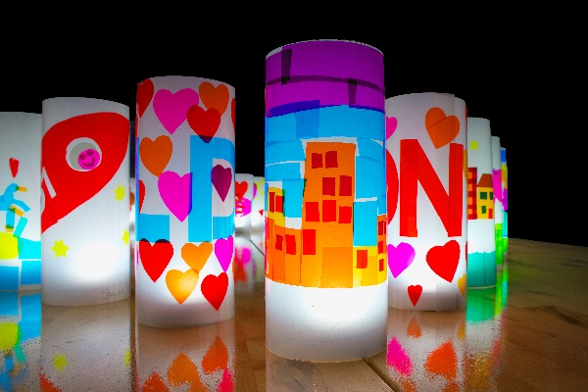

We are working with Tony Wade Art on a 'Shine a light on Learning Disability Nursing' project. The aim is to explore the positive careers in LD Nursing with year 6 Primary School children though a visual arts project.

Tony held a workshop for 1 year 6 class where pupils were shown a short Learning Disability Nursing video alongside words often used to describe LD nursing – Creative, Innovative, Passionate. The pupils had group discussions to explore how these words can be interpreted visually. The pupils made individual lanterns decorated with visual representations of those words. A lantern making workshop with adults with Learning Disabilities was held where the participants will create their own lanterns along the same themes as the year 6 pupils. A display of the lanterns was photographed and videoed. The photographs and videos can be found here:
Shining a Light on Learning Disability Nursing - YouTube

You can make your own lanterns all you need is a sheet of acetate on which to design artwork to make lanterns to promote LD Nursing. Lit with a battery-operated candle the plan is to light up the awareness around learning disability nursing. A video of how to make a Shine a light on LD Nursing lantern can be found here: How to make a lantern - YouTube

Thank you, Tony, for your support in celebrating Learning Disability Nurses Day.

Further information about Tonys work can be found here:
tony wade – making and sharing things (tonywadeart.com)

